Green Cross Sanitarium, Inc. – Luling, Caldwell, Texas
San Antonio Experess – 15 Mar 1931
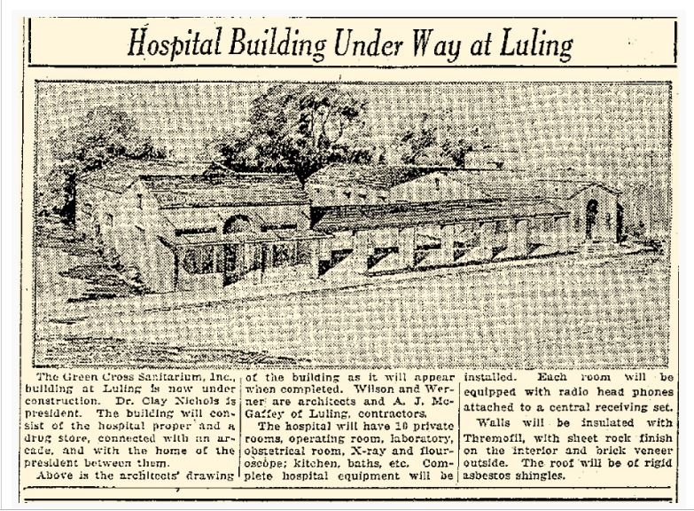
Building still stands at 518 Pierce Street and today houses the City of Luling Communications, Municipal Court and the Caldwell County Mental Health Center. The Green Cross symbol remains visible above the door. (Photo -Riley Froh)
